Name: Sergio Gutierrez

bitbucket Repo: <https://bitbucket.org/SergioZGutierrez/homework/src/master/>

Exercise 7 (there’s two).

This is the folder containing my apps, and java files:

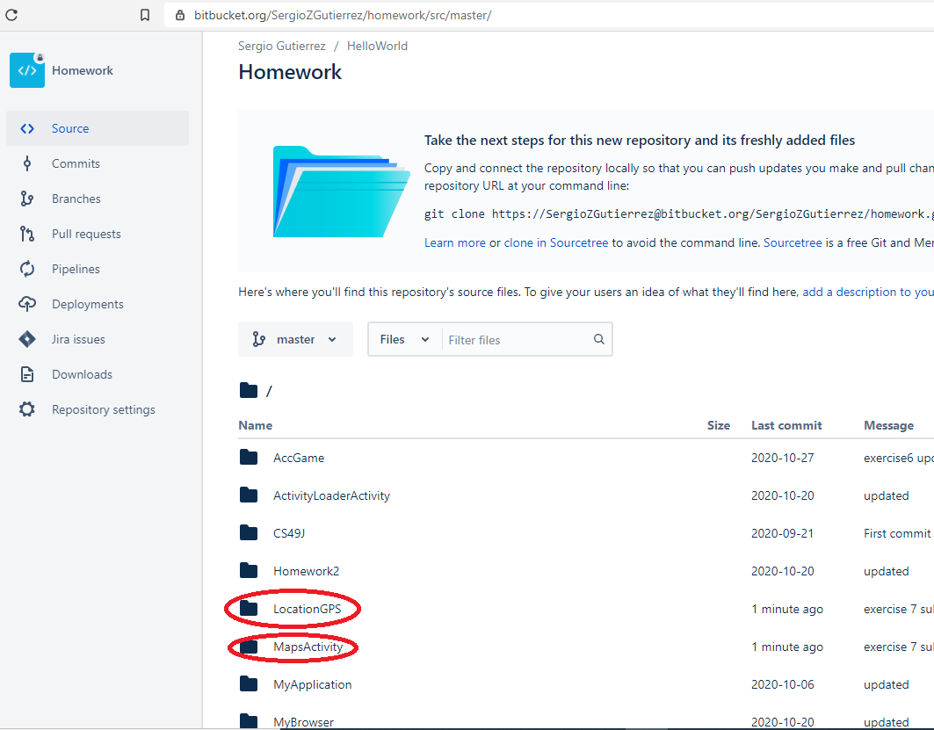

Exercise 7, first problem:

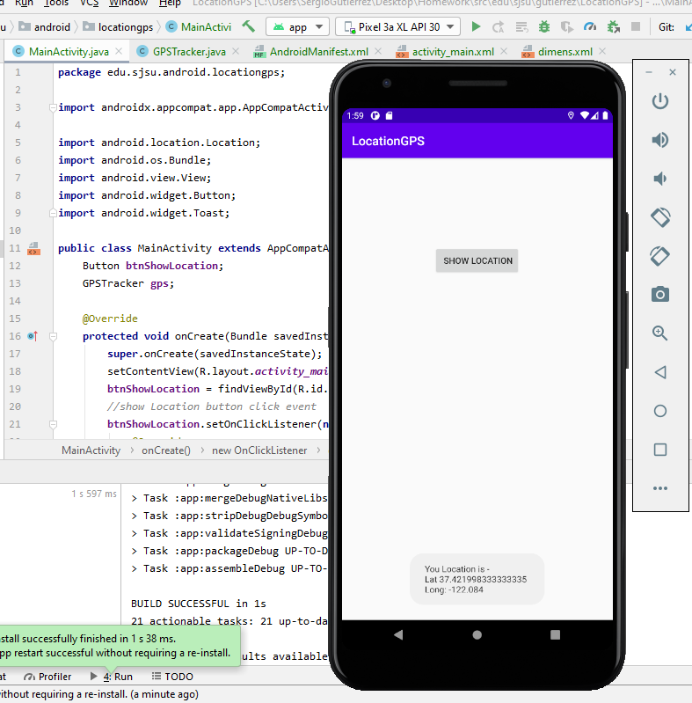

Second problem, three pictures:

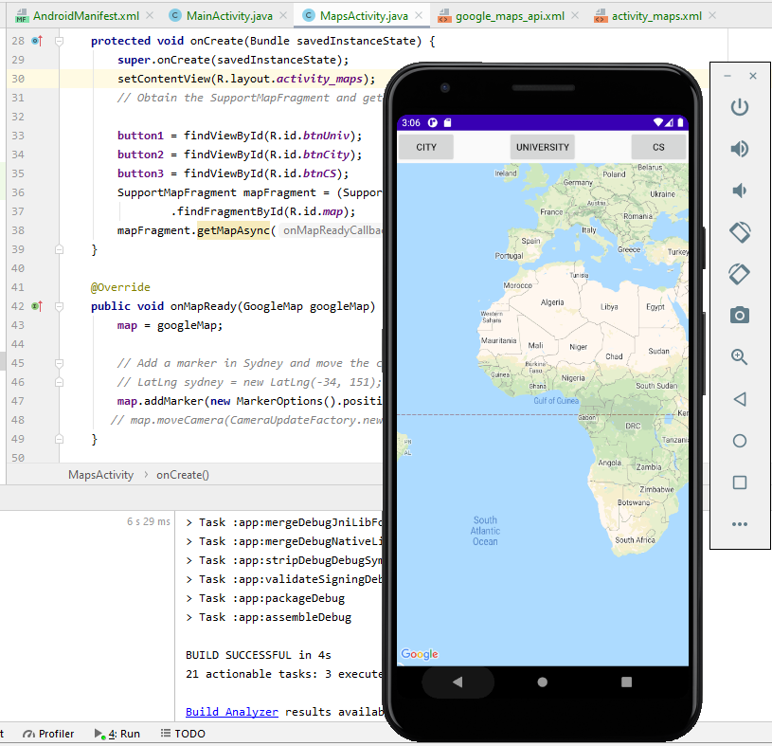

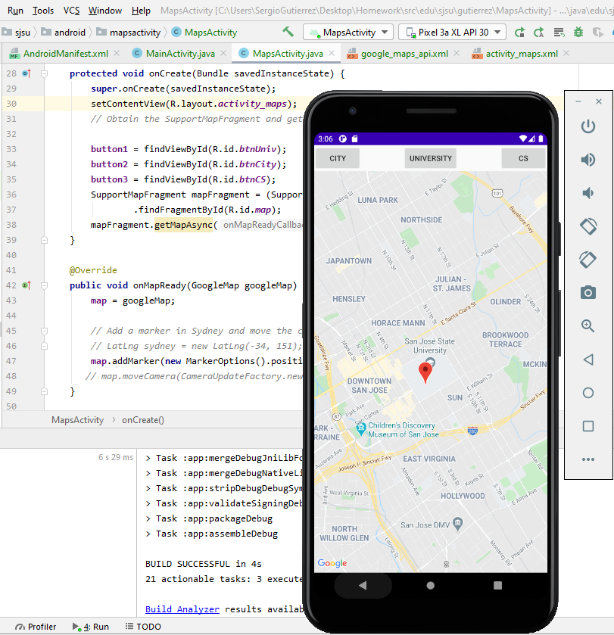

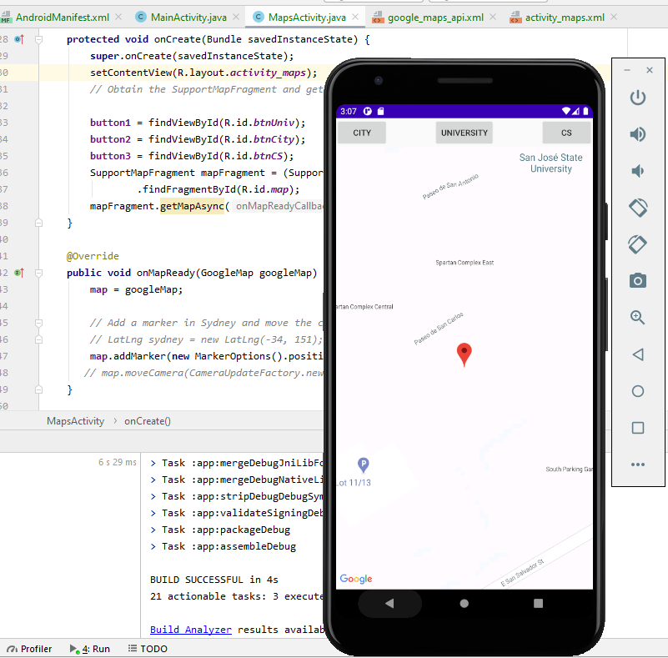

The exact pathway of where the .java files are located in my repository are:

<https://bitbucket.org/SergioZGutierrez/homework/src/master/LocationGPS/app/src/main/java/edu/sjsu/android/locationgps/>

and

<https://bitbucket.org/SergioZGutierrez/homework/src/master/MapsActivity/app/src/main/java/edu/sjsu/android/mapsactivity/>